Hi! Yoooo what's good…good luck on the project! peace

Thank you for helping us test our chrome dino game! This project was developed by Anjola Adewale, Chelsea Maramot and Sheridan Fong as part of our SFWRENG 3XA3 course.

After playing the game it would greatly help us if you can fill out this [feedback form](https://docs.google.com/forms/d/e/1FAIpQLScCjPPPoDTJELu4WutZN0nMitb9kS9Z-vHt_UPMZi2ktyv_sA/viewform?usp=sf_link). The form should only take one minute to complete.

Happy playing!

Team Rex (“ROAR”) 🦖

# Download Instructions

1. Download the the source.zip folder in this google folder
2. Extract (right click zip file and find extract) the source folder to your desired destination folder (this might take a while)
3. Open the extracted folder named “source”
4. Find the “chromedino.exe” file - The file type is “Application”
   1. In Windows 11, the file might appear as just “chromedino” without the .exe extension
5. Double click this file
6. You might get a warning message from windows
7. Click the More Info

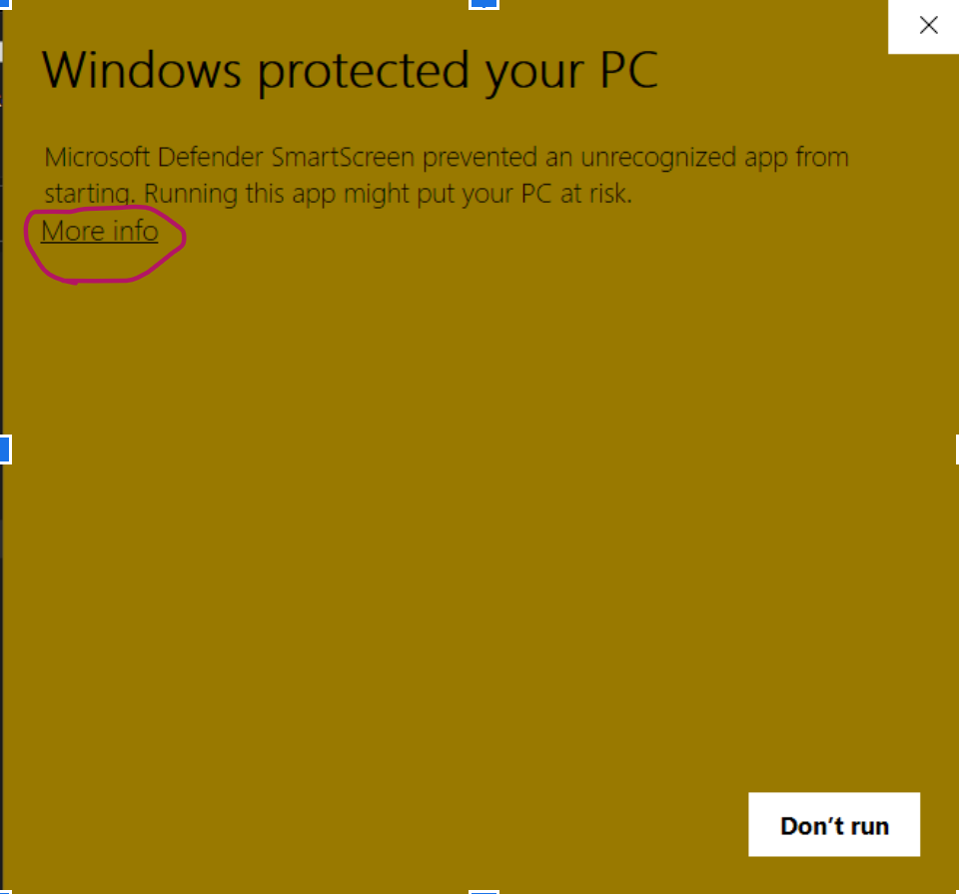

1. Then select Run Anyway on the next pop-up

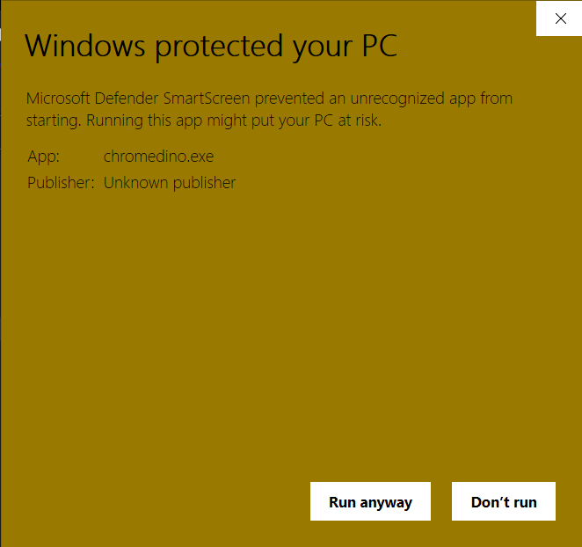

1. A terminal will pop up, do not click anything or close this window

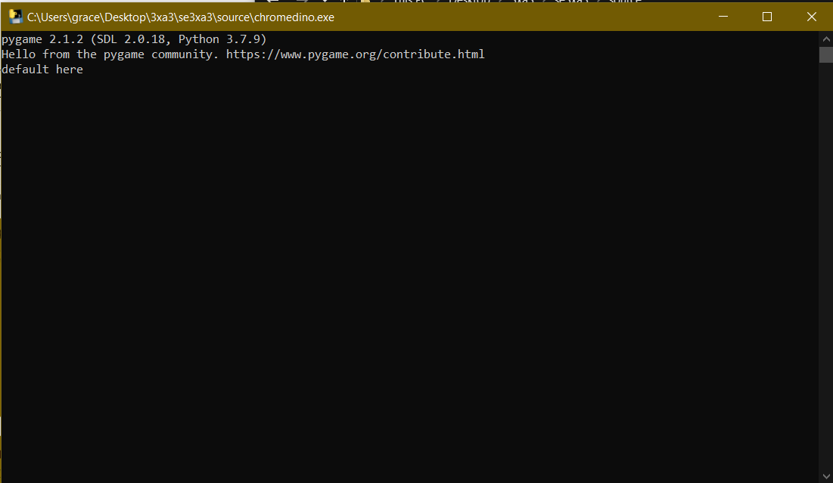

1. After about 30 seconds (at most) A second dialog box will pop up which is the game.  
   Do not quit/exit the black terminal as this will quit the game

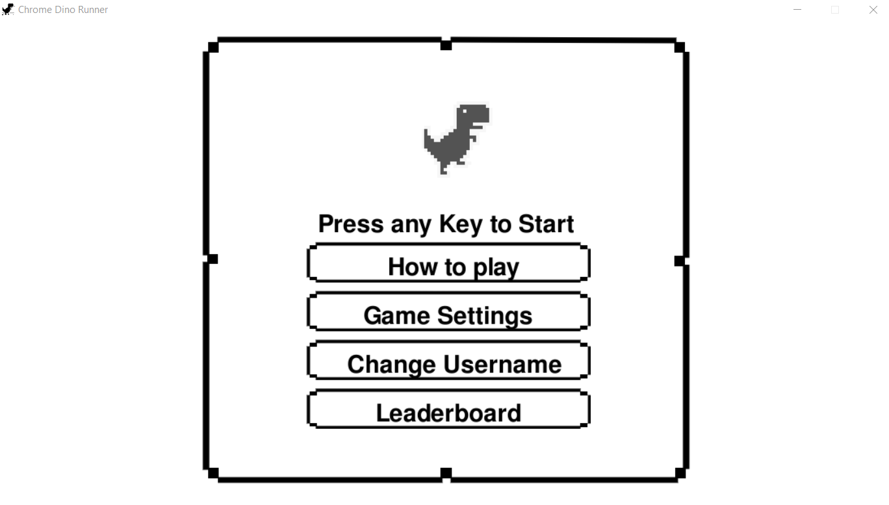

1. Play the game and explore
2. Fill out the [survey](https://docs.google.com/forms/d/e/1FAIpQLScCjPPPoDTJELu4WutZN0nMitb9kS9Z-vHt_UPMZi2ktyv_sA/viewform), please and thanks 🦖🦕